**ECE 254 Homework 6**

**Unknown Amplitude, Phase, and Frequency**

**Name: Mingxuan Wang**

**Date: 2015/11/22**

* Title: Unknown Amplitude, Phase, and Frequency
* Objective:

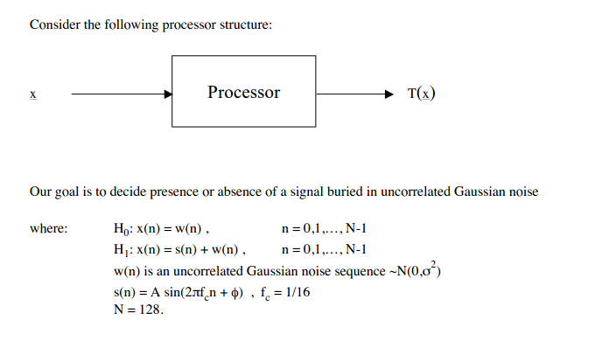

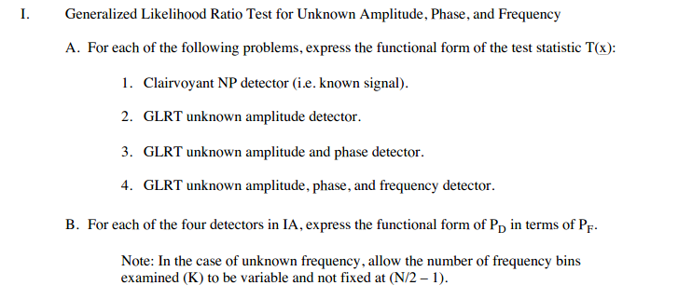

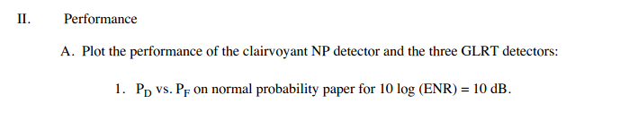

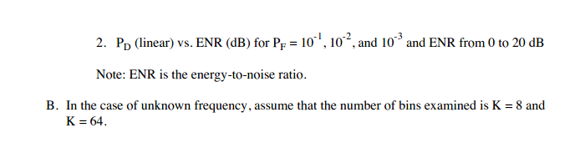

* Approach:

See handwriting.

* Results(including plots):



**Figure 1 PD vs PF clairvoyant NP detector and the three GLRT detectors**



**Figure 2 PD vs ENR clairvoyant NP detector**



**Figure 3 PD vs ENR SKEA**



**Figure 4 PD vs ENR SKEAP**



**Figure 5 PD vs ENR SKEAPF k=8**



**Figure 6 PD vs ENR SKEAPF k = 64**

**Discussion:**

1. For figure 1, we can see that, for GLRT Approach:
   1. From figure 1, we know that the rank of the performance is: clairvoyant NP detector > SKEA > SKEAP > SKEAPF.
   2. We know that clairvoyant NP detector is just SKE problem and we know everything of the signal. And after this, SKEA, SKEAP and SKEAPF have missing properties and each one has more than the previous one. So we can have the conclusion that the more unknown parameters we have, the larger the error is.
   3. This conclusion is not hard to understand. GLRT approach uses Maximum Likelihood Estimation for those unknown parameters and the error is larger when there is more parameters needed to be estimated.
   4. For SKEAPF problem, with the increasing of the PD, the error is larger and larger. And the performance is better when k = 8 compared to k = 64.
2. For figure 2 – 6, we know that:
   1. With the decrease of pf, the curve (pd vs ENR) turn to right a little bit each time.
   2. With the decrease of pf, the slope of the curve becomes steeper.
   3. With the increase of ENR, the performance becomes better.
   4. With different PF, the difference of PD when ENR is fixed in clairvoyant, SKEA, SKEAP is larger than SKEAPF, especially in low ENR.
   5. On a fixed PF in order to obtain PD=1 we need least ENR for clairvoyant NP or SKEA detector and the uncertain amplitude, phase and frequency needs more or larger ENR than others.
   6. We can still find that when k is large, the performance is worse. From the Approach part, we know that test statistic T(x) is related to k and In the case of unknown frequency, allow the number of frequency bins examined (K) to be variable and not fixed at (N/2 – 1).

**Appendix:**

**Hw6.m**

**%% PD vs PF**

**% clairvoyant NP detector**

**ENR=10.^(10/10);**

**d=(ENR)^(1/2);**

**PFcnd=0.01:0.01:1;**

**PDcnd=Q(Qinv(PFcnd)-d);**

**figure(1)**

**probpaper(PFcnd,PDcnd, '-')**

**% SKEA**

**PFskea=0.01:0.01:1;**

**PDskea = Q(Qinv(PFskea/2)-d)+Q(Qinv(PFskea/2)+d);**

**figure(1)**

**hold on**

**probpaper(PFskea,PDskea, ':')**

**% SKEAP**

**PFskeap=0.01:0.01:1;**

**PDskeap=zeros(1,100);**

**for i=1:100**

**PDskeap(i)=Qchipr2(2,ENR,2*log(1./PFskeap(i)),1e-5);**

**end**

**figure(1)**

**probpaper(PFskeap,PDskeap, '-.')**

**% SKEAPF k = 8**

**PFskeapf=0.01:0.01:1;**

**K1=8;**

**x1=-2*log(1-(1-PFskeapf).^(1/K1));**

**PDskeapf8=zeros(1,100);**

**for i=1:100**

**PDskeapf8(i)=Qchipr2(2,ENR,x1(i),1e-5);**

**end**

**figure(1)**

**probpaper(PFskeapf,PDskeapf8, '--')**

**% SKEAPF k = 64**

**PFskeapf=0.01:0.01:1;**

**K2=64;**

**x2=-2*log(1-(1-PFskeapf).^(1/K2));**

**PDskeapf64=zeros(1,100);**

**for i=1:100**

**PDskeapf64(i)=Qchipr2(2,ENR,x2(i),1e-5);**

**end**

**figure(1)**

**probpaper(PFskeapf,PDskeapf64,'y')**

**legend('clairvoyant NP detector','SKEA','SKEAP','SKEAPF k = 8','SKEAPF k = 64');**

**%% PD vs ENR**

**PFA1=10^-1;**

**PFA2=10^-2;**

**PFA3=10^-3;**

**ENR=0:0.5:20;**

**lamda=10.^(ENR./10);**

**% clairvoyant NP detector**

**d=(10.^(ENR/10)).^(1/2);**

**PDske1=Q(Qinv(PFA1)-d);**

**PDske2=Q(Qinv(PFA2)-d);**

**PDske3=Q(Qinv(PFA3)-d);**

**figure(2)**

**plot(ENR,PDske1,'-')**

**hold on**

**plot(ENR,PDske2,':')**

**plot(ENR,PDske3,'-.')**

**grid;**

**title('PD vs ENR clairvoyant NP detector');**

**xlabel('ENR/dB');ylabel('PD');**

**legend('0.1','0.01','0.001');**

**% SKEA**

**PDskea1=Q(Qinv(PFA1/2)-d)+Q(Qinv(PFA1/2)+d);**

**PDskea2=Q(Qinv(PFA2/2)-d)+Q(Qinv(PFA2/2)+d);**

**PDskea3=Q(Qinv(PFA3/2)-d)+Q(Qinv(PFA3/2)+d);**

**figure(3)**

**plot(ENR,PDskea1,'-')**

**hold on**

**plot(ENR,PDskea2,':')**

**plot(ENR,PDskea3,'-.')**

**grid;**

**title('PD vs ENR SKEA');**

**xlabel('ENR/dB');ylabel('PD');**

**legend('0.1','0.01','0.001');**

**% SKEAP**

**PD1skeap=zeros(1,41);**

**PD2skeap=zeros(1,41);**

**PD3skeap=zeros(1,41);**

**for i=1:41**

**PD1skeap(i)=Qchipr2(2,lamda(i),2*log(1./PFA1),1e-5);**

**PD2skeap(i)=Qchipr2(2,lamda(i),2*log(1./PFA2),1e-5);**

**PD3skeap(i)=Qchipr2(2,lamda(i),2*log(1./PFA3),1e-5);**

**end**

**figure(4)**

**plot(ENR,PD1skeap,'-')**

**hold on**

**plot(ENR,PD2skeap,':')**

**plot(ENR,PD3skeap,'-.')**

**grid;**

**title('PD vs ENR SKEAP');**

**xlabel('ENR/dB');ylabel('PD');**

**legend('0.1','0.01','0.001');**

**% SKEAPF k = 8**

**K1=8;**

**x1=-2*log(1-(1-PFA1).^(1/K1));**

**x2=-2*log(1-(1-PFA2).^(1/K1));**

**x3=-2*log(1-(1-PFA3).^(1/K1));**

**PD1skeapf=zeros(1,41);**

**PD2skeapf=zeros(1,41);**

**PD3skeapf=zeros(1,41);**

**for i=1:41**

**PD1skeapf(i)=Qchipr2(2,lamda(i),x1,1e-5);**

**PD2skeapf(i)=Qchipr2(2,lamda(i),x2,1e-5);**

**PD3skeapf(i)=Qchipr2(2,lamda(i),x3,1e-5);**

**end**

**figure(5)**

**plot(ENR,PD1skeapf,'-')**

**hold on**

**plot(ENR,PD2skeapf,':')**

**plot(ENR,PD3skeapf,'-.')**

**grid;**

**title('PD vs ENR SKEAPF k = 8');**

**xlabel('ENR/dB');ylabel('PD');**

**legend('0.1','0.01','0.001');**

**% SKEAPF k = 64**

**K2=64;**

**x4=-2*log(1-(1-PFA1).^(1/K2));**

**x5=-2*log(1-(1-PFA2).^(1/K2));**

**x6=-2*log(1-(1-PFA3).^(1/K2));**

**PD4skeapf=zeros(1,41);**

**PD5skeapf=zeros(1,41);**

**PD6skeapf=zeros(1,41);**

**for i=1:41**

**PD4skeapf(i)=Qchipr2(2,lamda(i),x4,1e-5);**

**PD5skeapf(i)=Qchipr2(2,lamda(i),x5,1e-5);**

**PD6skeapf(i)=Qchipr2(2,lamda(i),x6,1e-5);**

**end**

**figure(6)**

**plot(ENR,PD4skeapf,'-')**

**hold on**

**plot(ENR,PD5skeapf,':')**

**plot(ENR,PD6skeapf,'-.')**

**grid;**

**title('PD vs ENR SKEAPF k = 64');**

**xlabel('ENR/dB');ylabel('PD');**

**legend('0.1','0.01','0.001');**